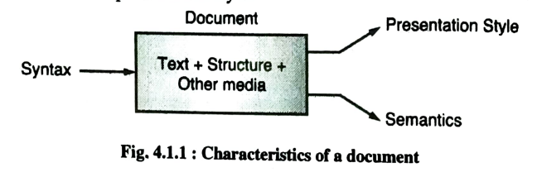

Characteristics of a document:

1. Syntax
2. Presentation style
3. Semantics

1. Syntax:

- Syntax refers to the structure and organization of the document.

- It includes aspects such as grammar, punctuation, and the rules governing how words and symbols are arranged.

- Syntax ensures that the document is well-structured and follows a coherent order of information.

- For example, in a written document, proper syntax ensures that sentences are correctly formed, paragraphs are structured logically, and headings and subheadings follow a consistent pattern.

2. Presentation Style:

- Presentation style relates to the visual and formatting elements of the document.

- It encompasses aspects like font choice, text size, color, layout, headings, bullet points, and overall design.

- Presentation style influences how the document looks and feels, making it more appealing and readable for the audience.

- For example, a professional report might use a formal presentation style with consistent fonts and headings, while a creative poster might use vibrant colors and various fonts to capture attention.

3. Semantics:

- Semantics deals with the meaning of the content within the document.

- It focuses on how words, phrases, and symbols convey the intended message.

- Semantics ensures that the document is clear, accurate, and effectively communicates its purpose to the reader.

- For example, in a legal contract, semantics are crucial to ensure that the terms and conditions are unambiguous and legally sound. In a scientific paper, semantics ensure that the terminology used accurately represents the concepts being discussed.

Metadata is information about information. It provides a structured way to describe, manage, and understand various aspects of data and resources. Metadata helps people, computers, and software systems discover, access, and manage data efficiently. Here's a detailed explanation:

1. **Definition**: Metadata is essentially data that describes other data. It provides information about the characteristics, attributes, and properties of data or resources, enabling users to find, use, and manage them effectively.

2. **Types of Metadata**:

- **Descriptive Metadata**: This type describes the content and context of the data. It includes information such as titles, author names, publication dates, abstracts, keywords, and more. For example, in a library catalog, descriptive metadata provides information about a book's title, author, and subject.

- **Administrative Metadata**: Administrative metadata helps manage resources. It includes information related to access control, rights management, preservation, and resource versions. In a digital library, it may record who has permission to access a document and how long it should be retained.

- **Structural Metadata**: This type describes the structure and relationships within a resource. For example, in a video file, structural metadata could indicate the order of scenes and chapters.

3. **Examples of Metadata**:

- **Digital Media**: In digital photos, metadata often includes information about the camera model, exposure settings, date and time taken, and GPS coordinates (geolocation).

- **Library Catalogs**: In library databases, metadata for a book might include the author's name, title, publication date, ISBN, and subject classifications.

- **Web Pages**: Metadata in HTML, such as the "title" tag, "meta" tags, and "alt" attributes for images, helps search engines and browsers understand and index web content.

4. **Importance of Metadata**:

- **Search and Discovery**: Metadata makes it easier to find and retrieve specific data or resources. It improves search engine results and enables users to quickly locate what they need.

- **Resource Management**: Metadata assists in organizing and managing digital assets, ensuring proper access control, preservation, and version tracking.

- **Interoperability**: Metadata allows different systems and applications to communicate and understand each other's data by following standardized formats and conventions.

- **Data Quality and Trust**: Well-maintained metadata enhances data quality and reliability, providing users with confidence in the information they access.

5. **Standards**: Many organizations and communities have developed metadata standards to ensure consistency and interoperability. Common metadata standards include Dublin Core, MARC (used in library cataloging), EXIF (for digital photos), and more.

6. **Metadata in the Digital Age**: With the growth of digital data and the internet, metadata has become even more crucial. Search engines, libraries, archives, content management systems, and digital asset management systems heavily rely on metadata to index, retrieve, and manage vast amounts of digital content.

In summary, metadata is essential for efficient data management and retrieval, and it plays a vital role in making data and resources more accessible and usable in various domains, from libraries and archives to digital content on the web.

RDF

RDF stands for Resource Description Framework, and it is a framework for representing and linking data on the web. RDF is a fundamental technology in the field of semantic web and linked data, enabling the structured description of resources and their relationships. Here's an explanation of RDF:

1. **Triples**: RDF is based on the concept of triples, which consist of three parts:

- Subject: The resource or thing being described.

- Predicate: The property or relationship that connects the subject to an object.

- Object: The value or resource that is related to the subject through the predicate.

In a simple form, an RDF triple might look like this:

- Subject: "John"

- Predicate: "hasAge"

- Object: "30"

This triple expresses that "John has an age of 30."

2. **Graph Structure**: RDF data is often represented as a graph, where nodes represent resources, and edges (arcs) represent predicates or relationships between those resources. These graphs are called RDF graphs.

3. **Uniform Resource Identifiers (URIs)**: In RDF, resources are identified using URIs, which provide unique addresses for resources on the web. URIs can represent web pages, data entities, or even abstract concepts.

4. **Example**:

Let's say we want to represent information about a book using RDF. Here's how it might look:

- Subject (Book URI): "http://example.com/books/book1"

- Predicate: "title"

- Object (Literal): "Introduction to RDF"

- Predicate: "author"

- Object (Resource URI): "http://example.com/authors/jane_doe"

In this RDF data, we're describing a book ("Introduction to RDF") and its author (Jane Doe) using URIs and literals.

5. **Linked Data**: RDF is a core technology for the concept of linked data. It allows data to be connected across different sources, making it possible to navigate from one resource to another, enriching the web of data and enabling data integration and interoperability.

6. **Standards**: RDF is defined by the World Wide Web Consortium (W3C) and is often used with other W3C standards like SPARQL (a query language for RDF data) and OWL (Web Ontology Language) to create rich semantic data models.

7. **Applications**: RDF is widely used in various applications, including semantic search, data integration, knowledge graphs, and structured data on the web. It plays a significant role in making the web more intelligent and connected by allowing computers to understand and process data more effectively.

MARKUP

Markup is a method of adding extra information to text in a document to provide structure, formatting, or semantics. Markup is used to define elements or tags that describe how the content should be presented or interpreted. Markup can be applied to text documents, web pages, and data to make them machine-readable and human-readable.

There are two commonly known markup languages, HTML (Hypertext Markup Language) and XML (Extensible Markup Language), which serve different purposes:

1. **HTML (Hypertext Markup Language)**:

- HTML is the standard markup language for creating web pages and web applications.

- It uses a predefined set of tags to structure content and define the presentation of elements on a web page.

- HTML tags represent various components like headings, paragraphs, links, images, lists, and more.

- HTML is primarily focused on defining the layout and presentation of web content and is used in combination with CSS (Cascading Style Sheets) and JavaScript for creating interactive web pages.

- Simple language well suited for - multimedia, hypertext, display of data

- Example HTML tag: `<p>This is a paragraph.</p>`

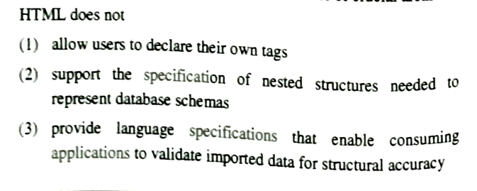

2. **XML (Extensible Markup Language)**:

- XML is a versatile markup language used for creating structured data in a format that is both human-readable and machine-readable.

- Unlike HTML, XML does not have predefined tags; it allows users to define their custom tags and structures based on the specific requirements of their data or content.

- XML is widely used in various domains, including data exchange, configuration files, document markup, and more.

- Example XML tag: `<person><name>John</name><age>30</age></person>`

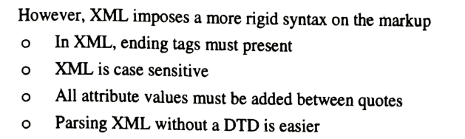

Both HTML and XML are text-based and use angle brackets `< >` to enclose tags. They are designed to be platform-independent, making it easier to exchange and share information across different systems and applications. However, their key differences lie in their intended use cases:

- HTML focuses on the presentation and structure of web content, making it user-friendly for web browsers.

- XML focuses on structuring data and is commonly used for representing information in a way that can be processed and interpreted by software applications.

In summary, markup languages like HTML and XML are essential tools for structuring and presenting information, whether for creating web content (HTML) or encoding structured data (XML). They help define the meaning and structure of content and facilitate interoperability between different systems.

SGML

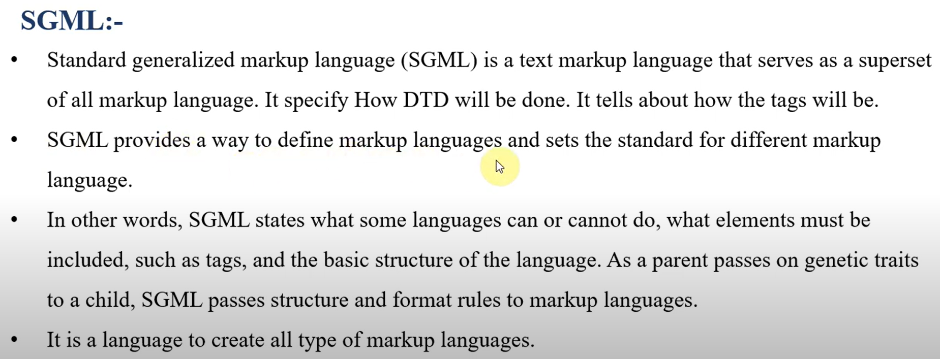

* Flexibility: SGML is highly customizable. Users can create their own Document Type Definitions (DTDs) to define the specific elements and rules for their documents. This flexibility allows SGML to be used in various industries and domains.
* Separation of Content and Presentation: SGML emphasizes the separation of content from its presentation. This means that SGML documents focus on the structure and semantics of the content, leaving the presentation details to be handled separately.
* Hierarchical Structure: Documents created with SGML have a hierarchical structure with nested elements. This allows for precise and complex document modeling.
* Complex Documents: SGML is well-suited for complex documents with multiple sections, chapters, tables, figures, and other structured content.

Multimedia is a term that refers to the integration of different types of media content, such as text, images, audio, video, graphics, and more, in a single presentation or application. Each component plays a unique role in creating a rich, engaging user experience. Here's an overview of these multimedia components:

1. **Text**:

- Text is a fundamental element of multimedia content, providing information and context.

- It includes written words and can be used for titles, captions, subtitles, and content descriptions.

- Text can enhance the understanding of other media elements.

RTF, PDF, HTML, Plain text

2. **Image**:

- Images are graphical representations that can include photographs, illustrations, icons, and more.

- They add visual appeal and can convey complex information quickly.

- Examples include product photos on e-commerce websites or infographics in presentations.

Jpeg, tiff, gif, png

3. **Audio**:

- Audio encompasses sound elements, such as music, spoken words, and ambient sounds.

- It can set the mood, provide narration, and enhance the emotional impact of multimedia presentations.

- Examples include background music in video games or voice-overs in educational videos.

Mp3, wav

4. **Video**:

- Video combines moving images and audio to convey information and engage users.

- It can be used for storytelling, demonstrations, tutorials, and entertainment.

- Examples include movies, YouTube videos, and video conferences.

Mpeg, mp4

5. **Graphics and Virtual Reality**:

- Graphics include various visual elements, from vector graphics to 3D models and animations.

- Virtual Reality (VR) takes graphics to the next level by creating immersive, interactive 3D environments.

- Examples include video games, architectural visualizations, and VR simulations.

Svg, 3d models

6. **HyTime**:

- HyTime is a standard for structuring and linking multimedia documents, allowing users to navigate and interact with multimedia content.

- It extends the concept of hyperlinks to multimedia, enabling users to explore non-linear, interactive content.

- While not as widely adopted as other multimedia components, HyTime has influenced the development of structured multimedia systems.

x3d

document clustering

types: local and global

local strategies- local clustering and local context analysis

Text processing applications are software programs or tools that analyze, manipulate, or extract information from text documents. Here, I'll provide a brief explanation of each application, along with examples and their theoretical concepts:

1. **Text Summarization**:

- **Theory**: Text summarization aims to condense a longer piece of text into a shorter version while preserving the most important information.

- **Example**: Automatic news article summarization tools that provide a concise summary of a news story.

2. **Text Classification**:

- **Theory**: Text classification involves categorizing text documents into predefined classes or categories based on their content.

- **Example**: Spam email filters that classify emails as spam or not spam based on their content.

3. **Named Entity Recognition (NER)**:

- **Theory**: NER identifies and extracts proper nouns, such as names of people, places, organizations, and more, from text.

- **Example**: Social media sentiment analysis tools that identify and analyze mentions of companies in tweets.

4. **Sentiment Analysis**:

- **Theory**: Sentiment analysis, or opinion mining, determines the sentiment or emotional tone expressed in a piece of text, such as positive, negative, or neutral.

- **Example**: Analyzing customer reviews to determine whether they express satisfaction or dissatisfaction with a product.

5. **Part-of-Speech Tagging (POS)**:

- **Theory**: POS tagging assigns grammatical categories (nouns, verbs, adjectives, etc.) to individual words in a text.

- **Example**: Language translation tools that rely on POS tagging to understand sentence structure.

6. **Information Extraction**:

- **Theory**: Information extraction identifies specific pieces of information within text, such as extracting dates, names, or events from news articles.

- **Example**: Extracting financial data from earnings reports for analysis.

7. **Text Clustering**:

- **Theory**: Text clustering groups similar documents together based on their content, helping to organize and retrieve related information.

- **Example**: Clustering news articles into topics like politics, sports, and entertainment.

8. **Text Generation**:

- **Theory**: Text generation creates new text based on predefined patterns or models, often used for chatbots, automated content generation, and more.

- **Example**: Chatbots that provide automated responses in natural language.

9. **Language Translation**:

- **Theory**: Language translation applications convert text from one language to another while preserving the meaning.

- **Example**: Online translation services like Google Translate.

10. **Information Retrieval**:

- **Theory**: Information retrieval systems retrieve relevant documents from a collection based on user queries or search terms.

- **Example**: Web search engines like Google, which retrieve web pages related to user queries.

Text Compression

1. Statistical methods

2. Huffman coding

3. Dictionary methods

4. Inverted File compression